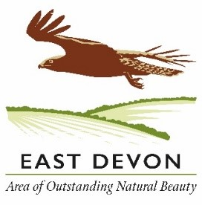
I walked the East Devon Way
East Devon Area of Outstanding Natural Beauty challenge
The East Devon Way follows a 40 mile route from Exmouth to Lyme Regis, through the beautiful East Devon Area of Outstanding Natural Beauty (AONB).
To celebrate those who walk the entire route, we have created a special certificate of achievement.
Complete the form below then send to the AONB office and your certificate will be sent to you; alternatively you can email the form to info@eastdevonaonb.org.uk

Date | From | To | Distance miles
 |  | Total distance

Contact details
Name
Address
Postcode
Email (optional)

My most memorable moment was:
Send to: East Devon AONB Partnership, Kennaway House, Sidmouth, Devon EX10 8NG
We’d love to see your pictures too, so if you’d like to share them please email to info@eastdevonaonb.org.uk

